Lecture Notes: Genetic Algorithms for Undergraduates
1. Introduction to Genetic Algorithms (GAs)
1.1 What are Genetic Algorithms?
- Definition: Genetic Algorithms (GAs) are a class of optimization algorithms inspired by the process of natural selection and genetics.
- Purpose: They are used to find approximate solutions to optimization and search problems.
- Key Idea: Mimic the process of natural evolution to evolve solutions over generations.
1.2 Historical Background
- Origin: Introduced by John Holland in the 1970s.
- Inspiration: Based on Darwin's theory of natural selection and survival of the fittest.
1.3 Applications of Genetic Algorithms
- Engineering: Design optimization, robotics.
- Computer Science: Machine learning, neural networks.
- Economics: Portfolio optimization.
- Biology: Protein folding, evolutionary studies.
2. Basic Concepts of Genetic Algorithms
2.1 Population
- Definition: A set of potential solutions to the problem.
- Representation: Each individual in the population is represented as a chromosome (often a string of bits, numbers, or other data structures).
2.2 Chromosome and Genes
- Chromosome: A string of genes that represents a potential solution.
- Gene: A single element of the chromosome, representing a specific trait or parameter.
2.3 Fitness Function
- Definition: A function that evaluates how close a given solution is to the optimum.
- Purpose: To assign a fitness score to each individual in the population.
2.4 Selection
- Definition: The process of choosing individuals from the population to create offspring.
- Methods: Roulette wheel selection, tournament selection, rank selection.
2.5 Crossover (Recombination)
- Definition: The process of combining two parent chromosomes to produce offspring.
- Methods: Single-point crossover, multi-point crossover, uniform crossover.
2.6 Mutation
- Definition: The process of randomly altering genes in a chromosome.
- Purpose: To introduce genetic diversity and prevent premature convergence.
2.7 Elitism
- Definition: A strategy that ensures the best individuals are carried over to the next generation without alteration.
- Purpose: To preserve the best solutions found so far.
3. The Genetic Algorithm Process
3.1 Initialization
- Step: Create an initial population of random solutions (chromosomes).
3.2 Evaluation
- Step: Evaluate the fitness of each individual in the population using the fitness function.
3.3 Selection
- Step: Select individuals based on their fitness scores to create a mating pool.
3.4 Crossover
- Step: Perform crossover on selected pairs of parents to produce offspring.
3.5 Mutation
- Step: Apply mutation to the offspring to introduce variability.
3.6 Replacement
- Step: Replace the old population with the new population of offspring.
3.7 Termination
- Step: Check if the termination condition is met (e.g., maximum number of generations, satisfactory fitness level). If not, repeat from Evaluation.
4. Example: Solving a Simple Optimization Problem
4.1 Problem Statement
- Objective: Maximize the function f(x)=x2f(x)=x2 where xx is an integer between 0 and 31.
4.2 Steps
- Initialization: Create a population of random 5-bit binary strings (e.g., 01010, 11001, etc.).
- Evaluation: Calculate the fitness of each individual by converting the binary string to a decimal number and squaring it.
- Selection: Use roulette wheel selection to choose parents.
- Crossover: Perform single-point crossover on selected parents.
- Mutation: Apply a small probability of flipping each bit in the offspring.
- Replacement: Replace the old population with the new population.
- Termination: Repeat until a maximum number of generations is reached or the optimal solution is found.
5. Advantages and Limitations of Genetic Algorithms
5.1 Advantages
- Global Search: Capable of finding global optima in complex search spaces.
- Robustness: Less likely to get stuck in local optima compared to traditional methods.
- Parallelism: Easily parallelizable, making them suitable for large-scale problems.
5.2 Limitations
- Computational Cost: Can be computationally expensive, especially for large populations and complex fitness functions.
- Parameter Sensitivity: Performance can be highly dependent on the choice of parameters (e.g., mutation rate, crossover rate).
- No Guarantee: Does not guarantee an optimal solution, only an approximate one.
6. Conclusion
6.1 Summary
- Genetic Algorithms are powerful optimization tools inspired by natural evolution.
- They involve processes like selection, crossover, and mutation to evolve solutions over generations.
- GAs are widely applicable but come with certain limitations.
6.2 Further Reading
- "Genetic Algorithms in Search, Optimization, and Machine Learning" by David E. Goldberg.
- Research papers on specific applications of GAs in various fields.
6.3 Questions for Discussion
- How does the choice of fitness function impact the performance of a genetic algorithm?
- What are some real-world problems where genetic algorithms have been successfully applied?
- How can the parameters of a genetic algorithm be tuned to improve its performance?

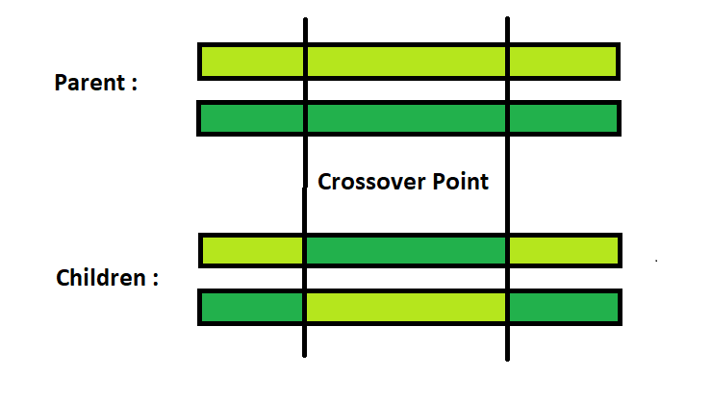

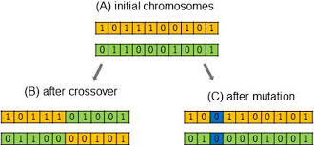
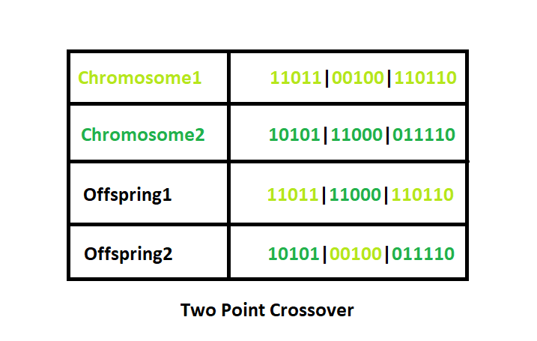

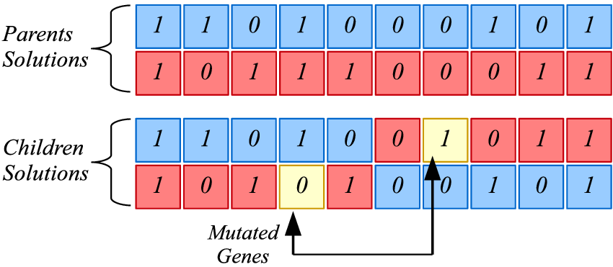
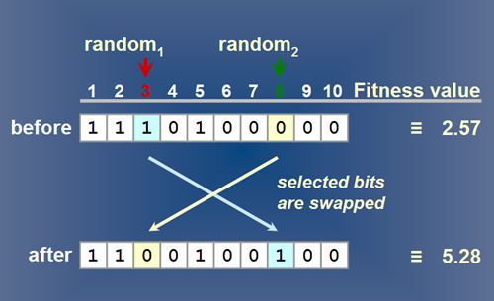



Evidence of MUTATION BELOW


